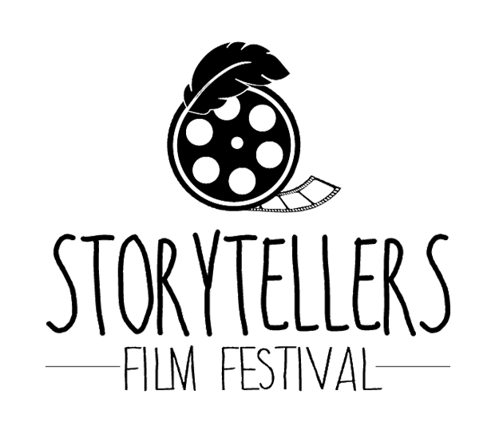

In March 2014 something new, exciting and unique came to the Tri-Area. Storytellers’ Film Festival opened the doors to local film makers, actors, and to those viewers who love the diversity known to festivals such as these.
Storytellers’ is not just a regular Film Festival. It is a Festival in which culture and our northern roots are celebrated. Indigenous film and northern people are showcased including the many talented movie makers from this area.
It was in 2014 that volunteers pulled together an incredible 3-day festival. Not only was there an amazing line up of shorts, documentaries, and human interest films but there were speakers and workshops. There were ceremonies, discussions and speeches. There was also food and drink. Many people from the industry were present and most had local ties or were still living in the area. Big film organizations sent representatives to participate and support the event.
The Festival was so well received that it could not be just a one- time affair and soon after the volunteer committee members ensured it would become an annual event.
The years that ensued were full of film previews, money searching and much organizing. One of the goals was to provide admission free of charge. This meant that finding grants and donations were required to make the event happen.
The Canadian Film Industry is an amazing organization. They are an organization who support film festivals and help to provide low or no cost admission by loaning out and sponsoring films at affordable costs.
Volunteers spend limitless hours previewing films and shorts, with the hopes of choosing the best entertainment for our area. Contact must then be made with the industry in order to secure the footage in time for the festival. Formatting, equipment testing and securing an ideal location as well as and many other tasks are spread amongst the committee members. Scheduling, advertising, organizing food and drink, venue selection and equipment rentals are also part of the adventure.
Hosting a film festival one really learns how to bring a community together. Film content can be heavy and deep but there are also lighter comedies, family programs and a children’s component. Increasingly there are films made by local people and starring local people. This is exciting to see!
During Storytellers’ 5th annual festival a workshop was held for youth to learn to create their own short film using their personal electronic devices. Several young people attended and in just a weekend’s worth of work they put together some amazing shorts. They showed the films to a full house on the final day. Such a huge feeling of pride was felt for each attendee and participant to see the success that was accomplished.
Our local communities are pulling together with support and encouragement. The Festival could not survive without the many local contributions. There are so many to acknowledge each year including: The Wescana Inn, UCN, Legion, TPCRC, Moffat Foundation, Arctic Beverages, TIFF, WFB, BellMTS - Stories From Home, Dennis Goulet, Coleen Rajotte, Shannon Goulet, Donna Janzen, Dennis Bignell, Steven Bignell, The Pas Arts Council, Bernhard Friz, Lorie Galenic Doucette, The Pas Regional Library, Tyson Poulin, Sam Karney, Bryce Gamache, Graham Constant, Zane Constant, Sound Innovations, Adam Halstrom, The Pas Community Renewal Corporation, Cheryl Antonio, Robin Marshall, Shadow Colomb, Canadian International Film Day, The Pas Helping Hands 4-H Club, and Oscar Lathlin Collegiate.
Storytellers’ Film Festival has successfully run in the spring over a period of 6 years. As long as there is funding and support we will continue to provide the event to the Tri-Community area. The committee utilizes a different venue each year in support of local business.
Submissions happens in February. If you are interested in what Storytellers’ Film Festival is doing please look us up on Facebook!
https://www.facebook.com/StoryTellersFilmFest/?epa=SEARCH_BOX

